Midterm part -1

Updating Kali:

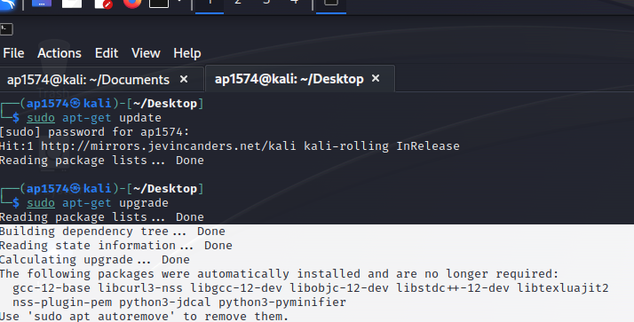

I’m using latest version kali and I have Metasploit already installed in it.

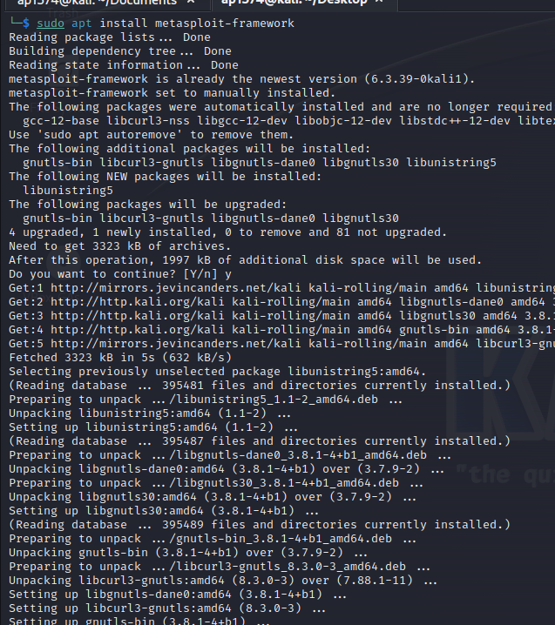

As you can see from the above screenshot Metasploit is already installed and its updating the packages to the latest.

Creating the staged payload:

Establishing connection with windows 7:

Successfully add the user “AdminAP1574”.

From Windows 7: we can see the Admin user is added successfully.

